Bayes Hit Disease Examples - Neurology
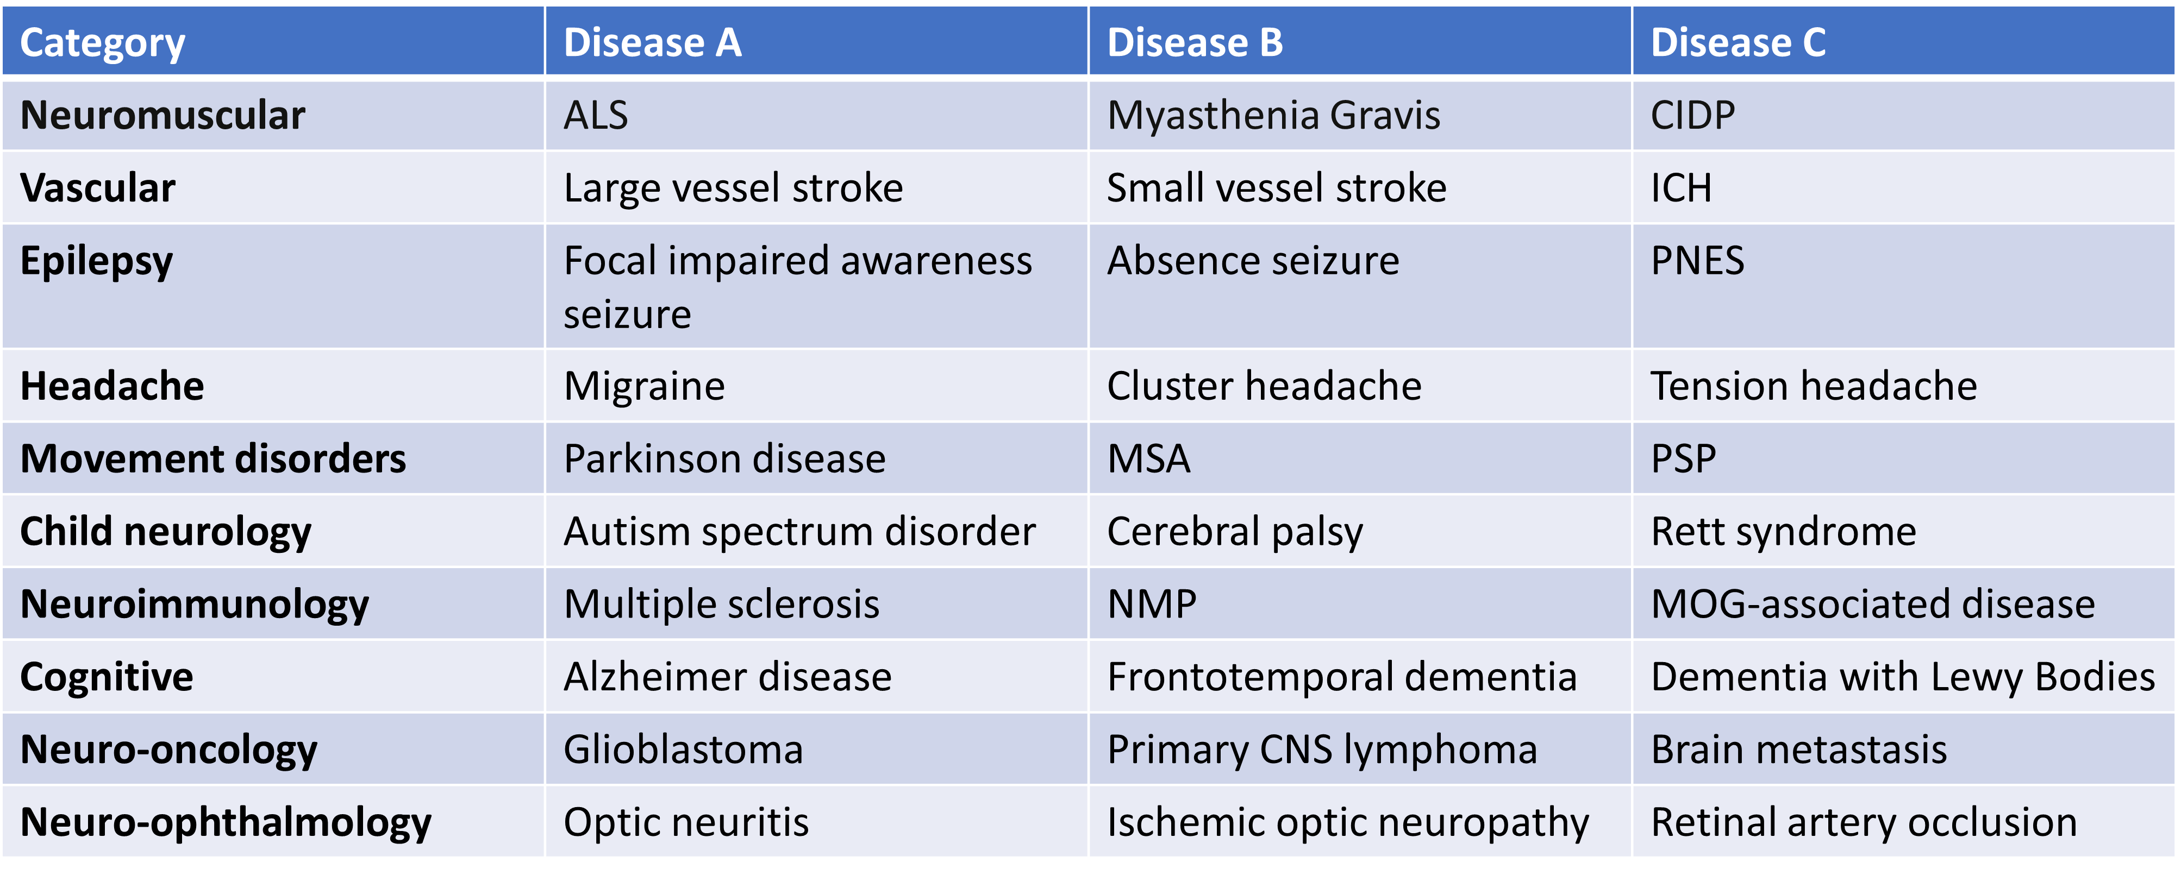

Bayes Hit Disease Examples – General Medicine
